Convolutional Neural Network

A Convolutional Neural Network also known as CNN or ConvNet, is a class of neural network that specializes in processing data that has a grid like topology such as image.

A digital image is a binary representation of visual data. It contains a series of pixels arranged in a grid like fashion that contains pixel values to denote how bright and what colour each pixel should be.

CNN helps to filter out patterns from an image which are known as features. These patterns filter helps to identify that is it present in an image or not.

Representation of image as a grid of pixels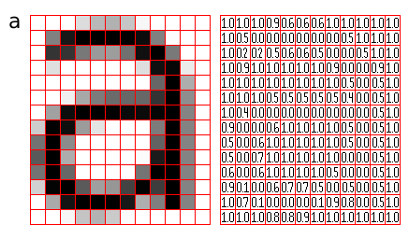

**CNN Architecture**

A CNN typically has two layers: a feature extraction layer and classification layer.

**Feature Extraction layer** contain the identification of position of pattern in the original image with the help of filters.

Filter can be any pattern identified/declared already by us. There could be number of filters, more the number of filters easy to identify any manipulation or variation of original image.

Here is an example of image declared with filters:

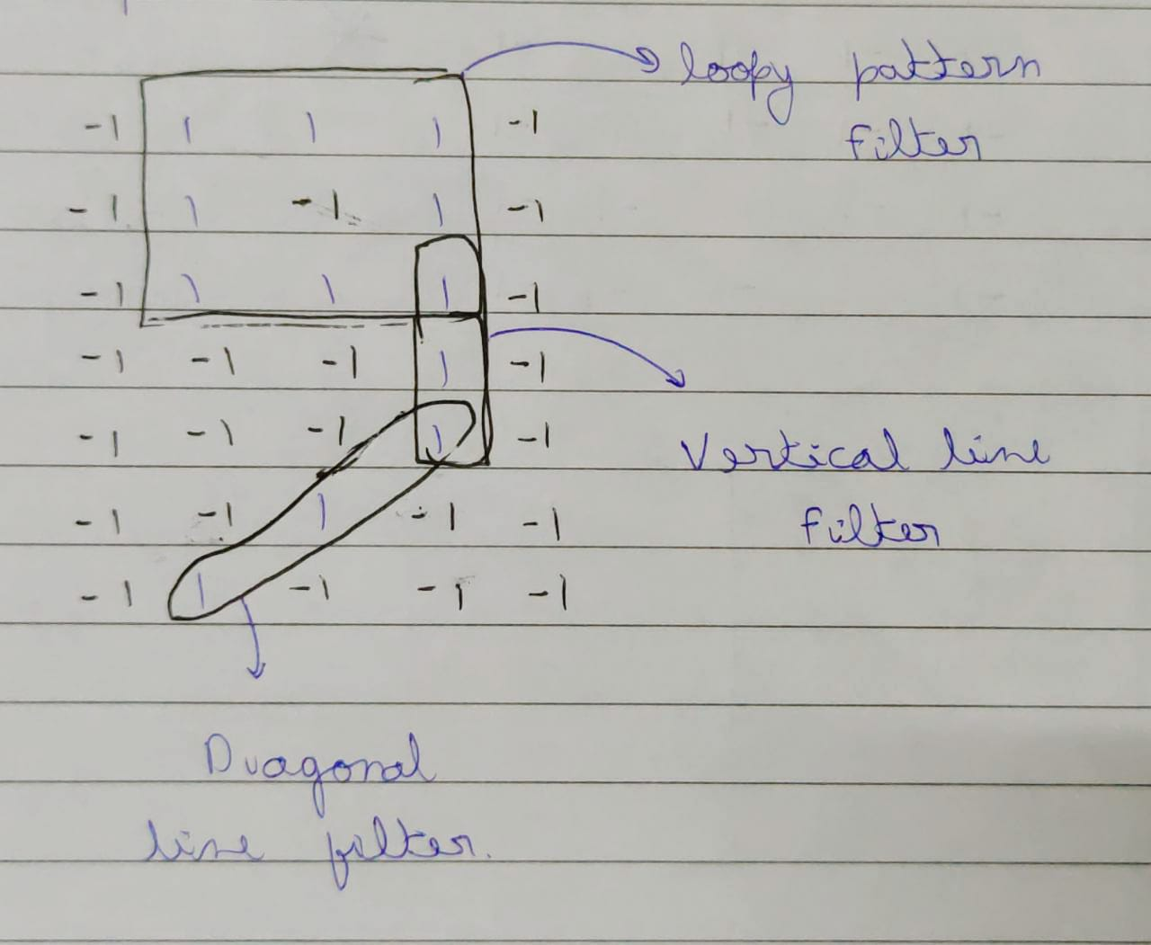

*Filters in an image*

An image contains many filters each filter has a matrix representation of pattern which helps to identify that an image contains this pattern or not.

Suppose taking the loopy pattern and apply convolutional operation to check if number ”9” contains this pattern or not

Convolutional operation takes the same size matrix as filter from original image and perform multiplication operation of each digit and form another matrix called as feature map.

This feature map gives value “1” where that pattern is identified else where it gives random value which might be negative also.

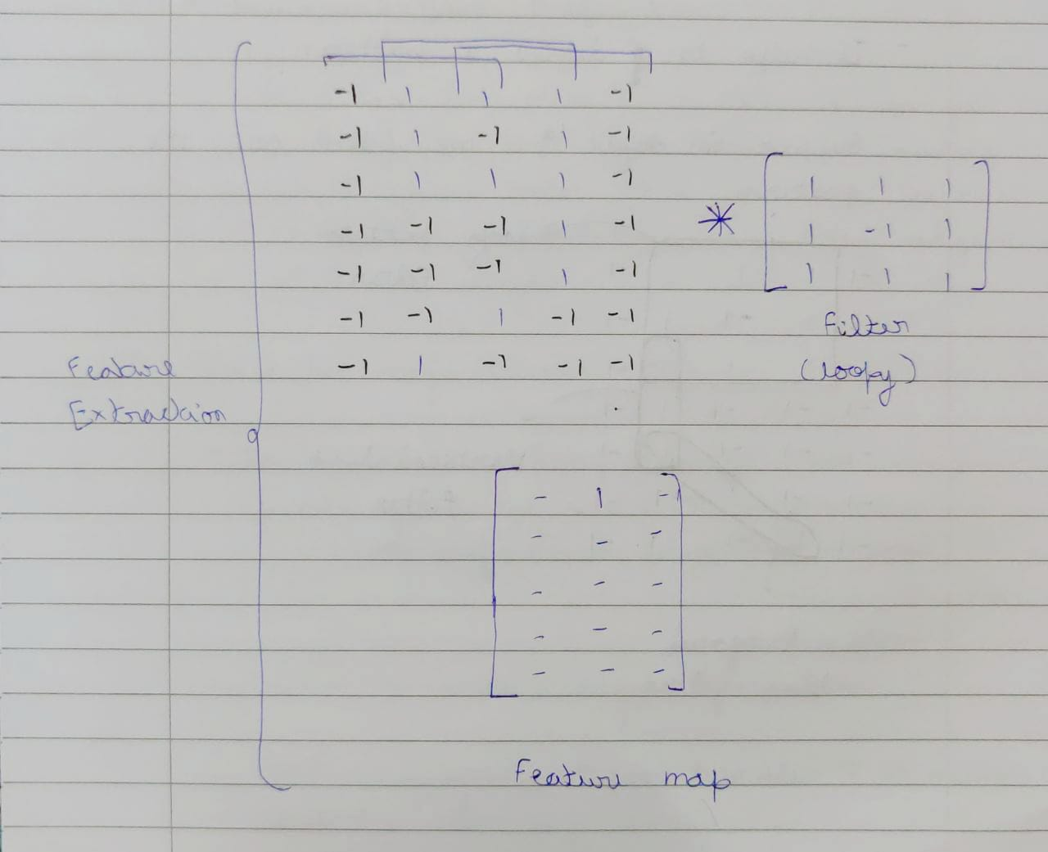*Feature Map Representation*

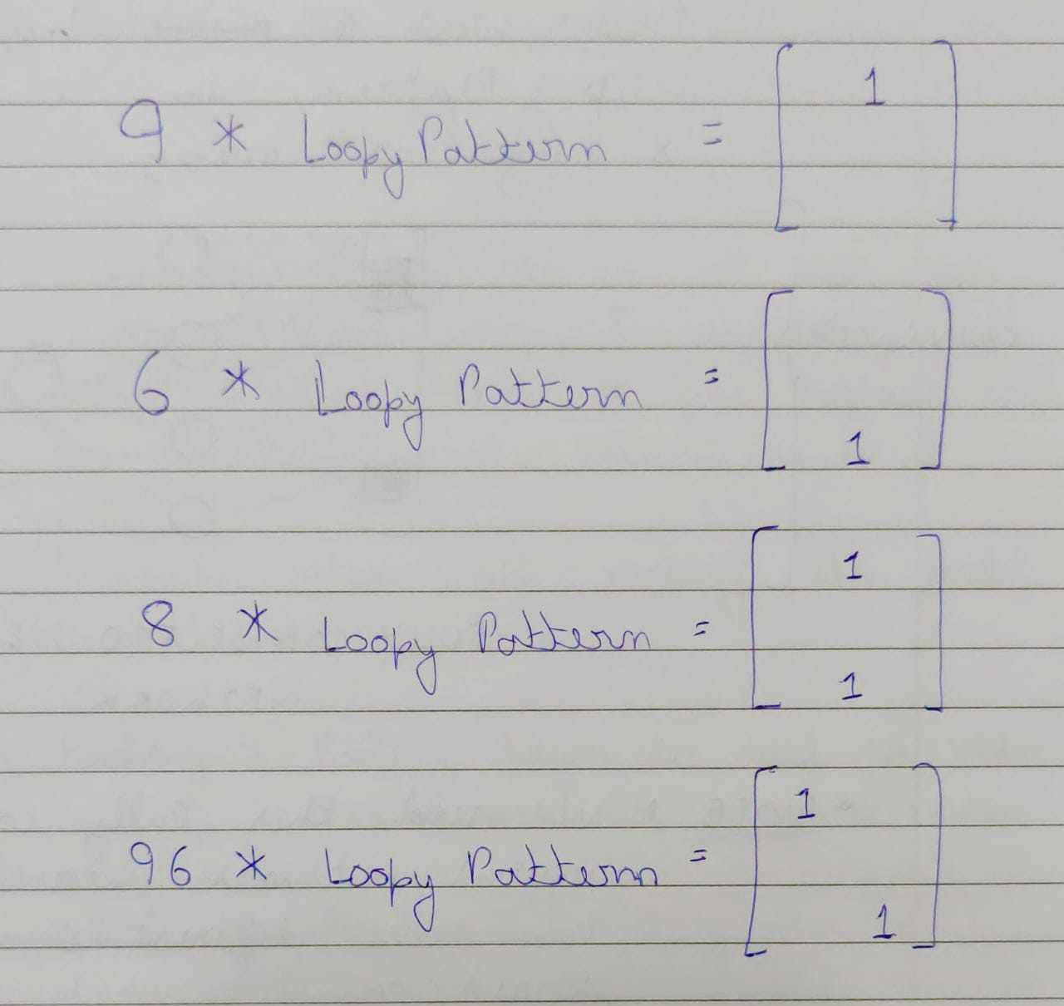Similarly, to find loopy pattern in other we can do the same process,

**Classification layer** merges all the features map and flatten to 1D array which forms fully connected neural network

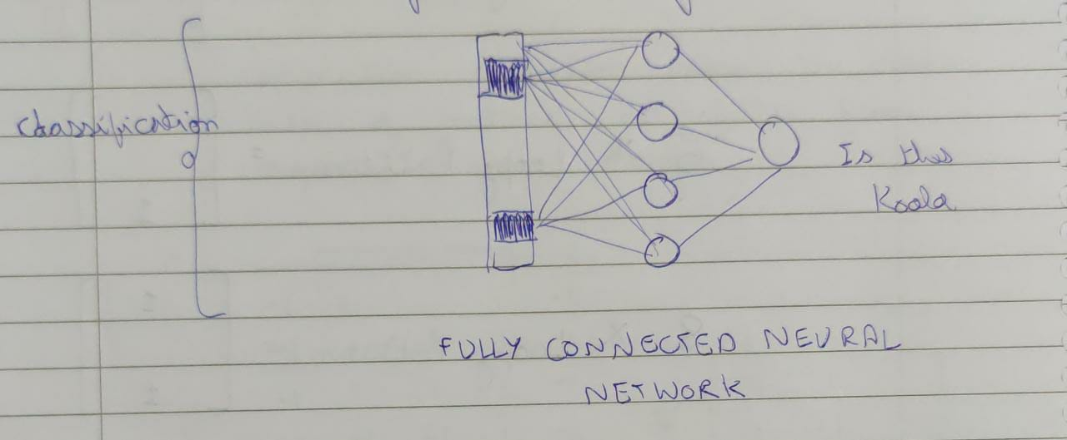

We need this fully connected neural network because we can have variation of single image which mans the input neuron (feature) are on different location which leads to generate a different type of flatten array.

Till now this is the gross view of CNN, there are two more component used in feature extraction layer:

1. ReLU (Rectified Linear Activation Function):

we use ReLU activation to bring non-linearity in our model.

So, what it will do is, it will take the feature map and whatever negative values are there it just replaces that with zero else keep it as it is.

1. Pooling:

Pooling layer used to reduce the size of matrix representation of filter

2.1) Max Pooling

2.2) Average Pooling

Complete Structure

